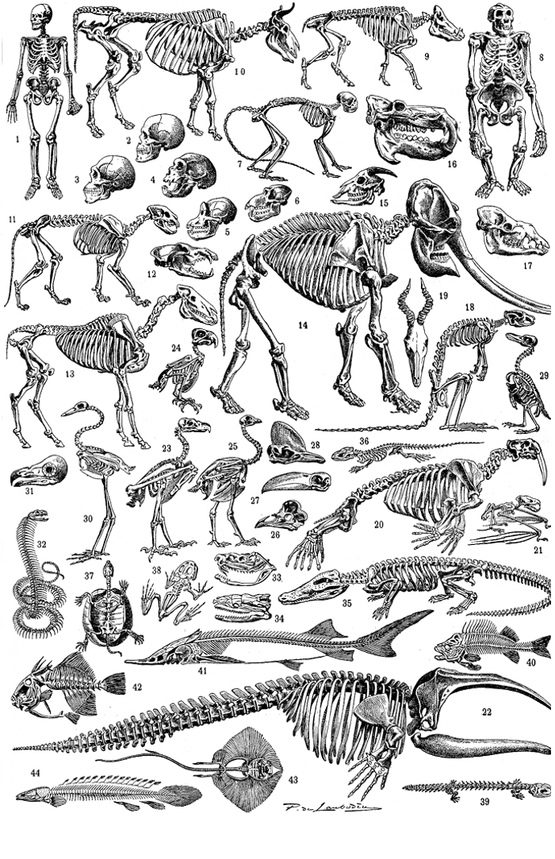

All in the Family: Evolution Student Sheet– From PBS Learning

Visit the following website and click Launch: http://illinois.pbslearningmedia.org/resource/tdc02.sci.life.evo.allinthefamily/all-in-the-family/

Part 1: Wolf, Shark and Dolphin

- What type of organism gave rise to life 3.8 billion years ago? ___________________

- What is one of the elephant’s closest living relatives? ____________________________

- Which 2 animals do you predict are most closely related?
(Dolphin, Shark, Wolf)

  - Go to Appearance:
    - Which 2 are the most similar in appearance? _____________________
  - Go to Anatomy:
    - Which 2 have the most similar limbs? _____________________________
    - Which 2 have the most similar jaws? ______________________________
    - Which 2 have the most similar cranium? _________________________

- What is the common ancestor of Dolphins, Wolves and Sharks? ________________

Part 2: Bear, Opossum and Raccoon

- Which 2 animals are most closely related? (Opossum, Bear, Raccoon)

  - Go to Appearance
    - Which 2 appear the most similar? _________________________________
  - Go to Anatomy
    - Which has a pouch? _________________________________________________
  - Go to Development
    - Which 2 have a placenta? ___________________________________________
    - Which 2 are the most developed at birth? ________________________
  - Go to Molecular
    - Which 2 Pairs have the most similar DNA sequence?
      - _______________________and_____________________
      - _______________________and_____________________

Part 3: Human, Sponge and Tunicate

- Which 2 species are most closely related? (Human, Sponge, Tunicate)
  - Go to Appearance
    - Which 2 appear the most similar? _________________________________
  - Go to Anatomy
    - Which 2 have a brains? _____________________________________________
  - Go to Development
    - Which 2 have a notochord? _________________________________________
    - Which 2 have gill arches? ___________________________________________
  - Go to Molecular
    - Which 2 Pairs have the most similar DNA sequence?
      - __________________and____________________
      - ___________________and____________________

Part 4: Research and Analysis (no longer on the website)

- What are some structures (other than appearance) that you can look at to determine how closely related different species are?

  - ________________________________________________________________________________

  - ________________________________________________________________________________

  - ________________________________________________________________________________

- Write down one of your favorite animals. ________________________________________

  - What other species do you think might be it’s closest relatives? _______

________________________________________________________________________________

  - Do some research online, who are the closest relatives? ________________

________________________________________________________________________________

- Why do you think they call it the Tree of Life?

Evolution: All in the Family - Student Companion Sheet

Visit the following website and click Launch: http://illinois.pbslearningmedia.org/resource/tdc02.sci.life.evo.allinthefamily/all-in-the-family/

Part 1: Wolf, Shark and Dolphin

- What type of organism gave rise to life 3.8 billion years ago? 1 Celled organisms

- What is one of the elephant’s closest living relatives? The hyrax

- Which 2 animals do you think are most closely related?
(Dolphin, Shark, Wolf)

  - Go to Appearance:
    - Which 2 are the most similar in appearance? Dolphin and Shark

  - Go to Anatomy:
    - Which 2 have the most similar limbs? Dolphin and Wolf
    - Which 2 have the most similar Jaws? Dolphin and Wolf
    - Which 2 have the most similar Cranium? Dolphin and Wolf

- What is the common ancestor of Dolphins, Wolves and Sharks? Lamprey

Part 2: Bear, Opossum and Raccoon

- Which 2 animals are most closely related? (Opossum, Bear, Raccoon)

  - Go to Appearance
    - Which 2 appear the most similar? Opossum and Raccoon

  - Go to Anatomy
    - Which has a pouch? Opossum

  - Go to Development
    - Which 2 have a placenta? Bear and Raccoon
    - Which 2 are the most developed at birth? Bear and Raccoon

  - Go to Molecular
    - Which 2 Pairs have the most similar DNA sequence?
      - Bear and Raccoon
      - Opossum and Echidna

Part 3: Human, Sponge and Tunicate

- Which 2 species are most closely related? (Human, Sponge, Tunicate)
  - Go to Appearance
    - Which 2 appear the most similar? Sponge and Tunicate

  - Go to Anatomy
    - Which has a brain? Human and Tunicate

  - Go to Development
    - Which 2 have a notochord? Humans and Tunicate
    - Which 2 have gill arches? Humans and Tunicate

  - Go to Molecular
    - Which 2 Pairs have the most similar DNA sequence?
      - Humans and Tunicates
      - Sponges and Choanoflagellate

Part 4: Research and Analysis (no longer on the website)

- What are some structures (other than appearance) that you can look at to determine how closely related different species are?

  - ________________________________________________________________________________

  - ________________________________________________________________________________

  - ________________________________________________________________________________

- Write down one of your favorite animals. ________________________________________

  - What other species do you think might be it’s closest relatives? _______

________________________________________________________________________________

  - Do some research online, who are the closest relatives? ________________

________________________________________________________________________________

- Why do you think they call it the Tree of Life?

