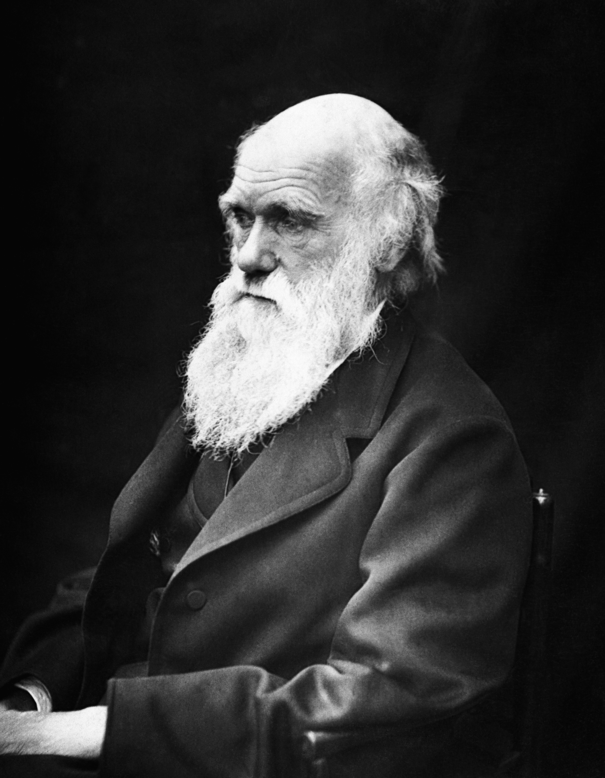

Name:____________________________________________________Date:_____________Period:__________

Charles Darwin Game of Survival Student Sheet

Visit the following Site:
http://www.sciencechannel.com/games-and-interactives/charles-darwin-game.htm Begin by clicking on “Learn About Natural Selection”

Part 1 Learn About Natural Selection

- What are some variations that a species can exhibit? ____________________________

________________________________________________________________________________________

- How are traits passed on? __________________________________________________________

- What traits do the parent finches pass on to their offspring? ____________________

_________________________________________________________________________________________

- What do we call it when the most beneficial traits are passed on? ______________

_________________________________________________________________________________________

Part 2 Survival of the fittest

- Select 3 variants of the species to begin the game.
  - Describe your 3 creatures and how they differ

    - ________________________________________________________________________

    - ________________________________________________________________________

    - ________________________________________________________________________

- Use a life preserver when your species is in trouble.

- Describe which traits have remained in your organism after the first chunk of time has passed. _____________________________________________________________________

- What natural disaster occurred? ___________________________________________________

- How many years did your species survive? _______________________________________

If you are not successful try again, remember that greater diversity of genetic traits is a good thing and don’t forget about your life preserver.

- Select 3 variants to begin the game.
  - Describe your 3 creatures and how they differ

    - ________________________________________________________________________

    - ________________________________________________________________________

    - ________________________________________________________________________

- Use a life preserver when your species is in trouble.

- Describe which traits have remained in your organism after the first chunk of

time has passed. _____________________________________________________________________

- What natural disaster occurred? ___________________________________________________

- How many years did your species survive? _______________________________________

Part 3: Darwin Bio – Read Darwin’s Biography

- What was the name of Darwin’s ship? _____________________________________________

- Where did he find many fossils? ___________________________________________________

- What was the name of his first book? _____________________________________________

Part 4: Quiz - Take the quiz. Get at least 8 out of ten correct to finish.

Part 5: Analysis – Explain why it is advantageous for a species to have a wide variety of traits. Use the animals that you worked with in the game as an example.

Charles Darwin Game of Survival Student Sheet

Visit the following Site:
http://www.sciencechannel.com/games-and-interactives/charles-darwin-game.htm Begin by clicking on “Learn About Natural Selection”

Part 1 Learn About Natural Selection

- What are some variations that a species can exhibit? Color, size, strength

- How are traits passed on? From parents to offspring

- What traits do the parent finches pass on to their offspring? Color, eyes and beak
- What do we call it when the most beneficial traits are passed on? “Survival of the fittest”

Part 2 Survival of the fittest

- Select 3 variants to begin the game.
  - Describe the 3 creatures and how they differ

    - Ex. Long Neck, red head

    - Ex. Long Legs, stripes

    - Ex. Brown Fur, short body

- Use a life preserver when your species is in trouble.

- Describe which traits have remained in your organism after the first chunk of time has passed. Ex. Most have long necks, long legs and spikes

- What natural disaster occurred? Ex. A new virus spreads

- How many years did your species survive? Ex. 777,777 years

If you are not successful try again, remember that greater diversity of genetic traits is a good thing and don’t forget about your life preserver.

- Select 3 variants to begin the game.
  - Describe the 3 creatures and how they differ

    - Ex. Long Neck, red head

    - Ex. Long Legs, stripes

    - Ex. Brown Fur, short body

- Use a life preserver when your species is in trouble.

- Describe which traits have remained in your organism after the first chunk of time has passed. Ex. Most have long necks, long legs and spikes

- What natural disaster occurred? Ex. A new virus spreads

- How many years did your species survive? Ex. 777,777 years

Part 3: Darwin Bio – Read Darwin’s Biography

- What was the name of Darwin’s ship? HMS Beagle

- Where did he find many fossils? South America

- What was the name of his first book? Origin of the Species

Part 4: Quiz - Take the quiz. Get at least 8 out of ten correct to finish.

Part 5: Analysis – Explain why it is advantageous for a species to have a wide variety of traits. Use the animals that you worked with in the game as an example.

Answers will vary

