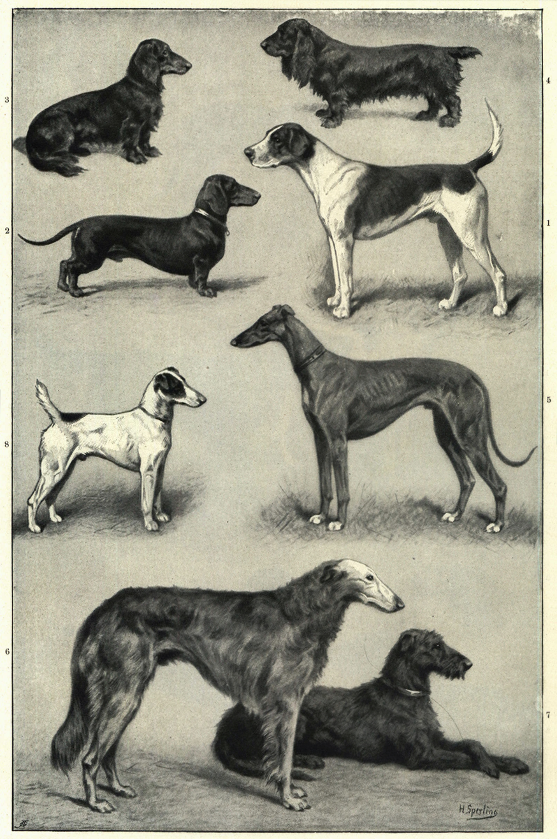

Dog Breeding Student Companion Sheet

Visit the following webpage to begin the simulation http://pbskids.org/dragonflytv/games/game_dogbreeding.html

The Goal is to breed certain types of border collie puppies by selecting parents with the correct traits. You are trying to match the correct coat color, length and ear type.

Begin on level 1 and work your way up to level 6.

Level 1:
- What trait are you breeding for? ___________________________________________________
- What genes does the Male dog have?
  - ________________________
  - ________________________
- What genes does the Female dog have?
  - ________________________
  - ________________________
- What is the probability of having a puppy with the desired traits? _____________
- How many spins did it take to get the desired traits? ____________________________

Level 2:
- What trait are you breeding for? ___________________________________________________
- What genes does the Male dog have?
  - ________________________
  - ________________________
- What genes does the Female dog have?
  - ________________________
  - ________________________
- What is the probability of having a puppy with the desired traits? _____________
- How many spins did it take to get the desired traits? ____________________________

Level 3:
- What trait are you breeding for? ___________________________________________________
- What genes does the Male dog have?
  - ________________________
  - ________________________
- What genes does the Female dog have?
  - ________________________
  - ________________________
- What is the probability of having a puppy with the desired traits? _____________
- How many spins did it take to get the desired traits? ____________________________

Remember, to find the probability of multiple traits you need to multiply the probability of each trait. For example ¼ X ¼ = 1/16

Level 4:
- What 2 traits are you breeding for?
- ________________________
- ________________________
- What is the probability of having a puppy with the desired traits? _____________

- Do you change the dogs that you are breeding to one of the offspring? ________

    - If yes, what is the new probability? ___________________________

- How many spins did it take to get the desired traits? ____________________________

Level 5:
- What 3 traits are you breeding for?
- ___________________________________
- ____________________________________
- ____________________________________
- What is the probability of having a puppy with the desired traits? _____________

- Do you change the dogs that you are breeding to one of the offspring? ________

    - If yes, what is the new probability? ___________________________

- How many spins did it take to get the desired traits? ____________________________

Level 6:
- What 3 traits are you breeding for?
- ___________________________________
- ____________________________________
- ____________________________________
- What is the probability of having a puppy with the desired traits? _____________

- Do you change the dogs that you are breeding to one of the offspring? ________

    - If yes, what is the new probability? ___________________________

- How many spins did it take to get the desired traits? ____________________________

Analysis Question
Visit a dog breed selector website (there are many). Enter your information to find out what type of dogs it recommends for you. Pick one of the breeds and do some additional research into what traits are common with that breed and on a separate sheet of paper write up the most important traits.

