How can energy be passed along?

To do:
- Set up dominoes in a line.
- Knock over the first domino and notice the motion of the other dominoes.

To think about:
- How far did each domino move?
- What traveled from the beginning of the line to the end of the line?
- Where did the energy to move the last domino come from?
- How is this related to waves?

Activity #2: (Racing Dominoes)

- Setup two lines of dominoes on a table or a large desk. In line one have the dominoes spaced far apart from one another, but close enough so when they fall they will able to knock over the next domino in line. The dominoes in line two should nearly be touching (See illustration). The lines must at least three feet long for the activity to work!

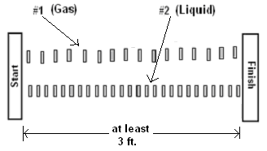

- Which line of dominoes will win the race and be the first to cross the finish line or will it be a tie?
____________________________________________________________________________________________________________________________________________________________

- Use a yard stick or book to start the race, knocking over the first domino in each line at the same time.
- Which line of dominoes fell the fastest? _____________________________________________
- The line of spread out dominoes represents which state of matter?_______________________
- How is the model similar to the real movement of sound waves in different media (phases of matter)? ____________________________________________________________________
- How could this model be improved to better represent how sound waves travel through matter? _______________________________________________________________________
- Will sound travel the fastest in air, water, or steel? (gas, liquid, or solid?) Why?
____________________________________________________________________________________________________________________________________________________________

