Name:_______________________________________________________Date:___________Core:_________

Glacier Simulation Activity

Objectives:

- Determine the factors that affect the motion of glaciers, and calculate the speed of glacier movement.

- Discover what a glacier budget means for the growth and destruction of a glacier, and describe the features it leaves behind.

Procedure:

- Open http://phet.colorado.edu/new/simulations/ and click on “Glacier”, or go to Google and type “phet” and click on the first link.

- * Turn off the snowfall effect. Play with simulation for 5 minutes. Grab the bear and change viewpoints, try to make the glacier grow/shrink. If the glacier disappears hit the “Reset All” button.

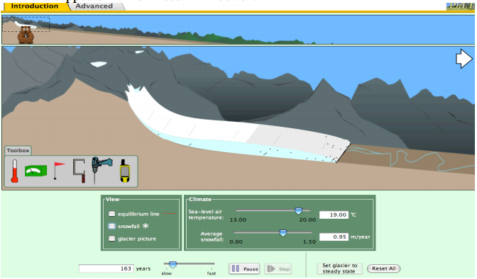
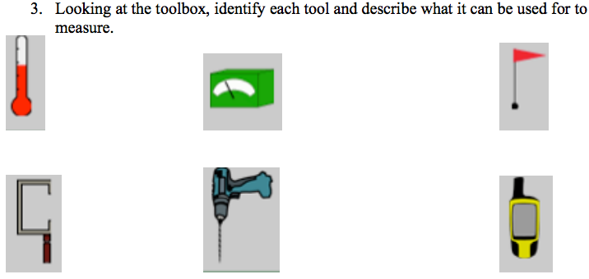

- Equilibrium line: This line indicates the boundary where the freezing meets the melting of the glacier. Change some factors and describe what happens to the equilibrium line and what happens to the glacier.

- When you set the temperature and snowfall; and hit the STEADY STATE button, what happens to the glacier?

Predictions

- If the average annual snowfall increases (m/yr), what will happen to the glacier?

- If the temperature changed, describe the two things that could change in the glacier.

- If the temperature is decreased and the snowfall is increased,

  - Will the equilibrium line move up the mountain or down the mountain? Explain.

  - What will this do to the glacier? (advance or retreat) Explain.

  - What will happen to the glaciers thickness and length if the climate change as #3 describes?

I. Glacier Speed

Using the toolbox you will determine the speed of a glacier, and what parts of a glacier move faster than others.

Drilling: Set to the temperature and snowfall to an amount that creates a decent sized glacier. Press the “STEADY STATE” button and Pause the motion of the glacier. Drill several vertical holes through the glacier.

- Draw a sketch of what the glacier looks like with the drill holes, before the glacier moves again.

- Press play and allow the glacier to move, draw a sketch of the drill holes, as the glacier is moving.

II. Glacier Observations
Many features are present when a glacier advances or retreats on a mountain slope.
Answer the following questions about the features of the glacier valley.

- What are the tiny black dots that move through the glacier? Where did this material originate? Where are the black dots deposited?

- Make the glacier retreat up the mountain. What happens to all the material that is moved with the glacier?

- Press RESET ALL, and set the glacier back to its starting location. Make the glacier completely melt away. Once this is done, increase the snowfall to maximum and decrease the temperature to its lowest point.

  - How many years will it take the glacier to return to its original position?

  - Could this occur in real life?

