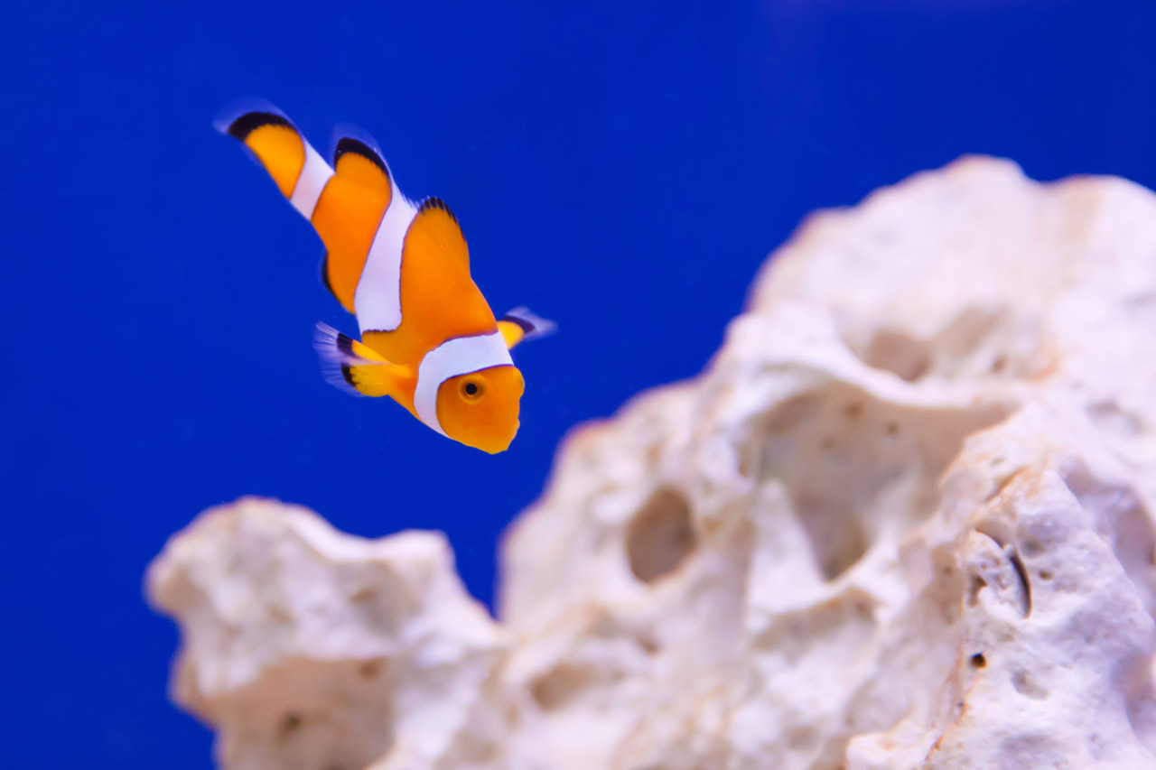

Your Inner Fish Student Companion Sheet

- What is Neil Shubin (the narrator) looking for?

- What job does Neil have?

- Fish were the first creatures with what trait?

- When did the first mammals show up?

- Sir Richard Owen was the first scientist to notice what skeletal pattern?

- Instead of limbs fish have what?

- Where did the paleontologists go for their first expedition?

- What type of environment was the Canadian Arctic hundreds of millions of years ago?

- In the early stages of development, all animals begin as what?

- If you look at a fish and human embryo side by side, how similar do they look?

- What does Molly possess that most humans do not?

- Where are fish gonads located?

- What is Sonic Hedgehog responsible for?
- How many fingers do people in the Hubbard family have?

- How far back can we trace the Sonic Hedgehog gene?

- What does the name Tiktaalik mean?

- Who was the first to predict that an animal like Tiktaalik would exist?

- What features does Tiktaalik have that fish typically do not?

- What type of exercise could Tiktaalik do that other fish cannot?

- What is the piece of anatomy that changed the world?

Analysis Questions

If a person wanted their child to have 6 fingers on each hand, explain how you think a doctor would be able to accomplish this.

Tiktaalik is a great example of a transitional animal that is in between a fish and an amphibian. Predict what the transitional animal that is between a reptile and a mammal might have been like. What features did it have that are mammalian, what features did it have that were reptilian? Draw a picture of what you think it looked like.

Your Inner Fish Student Companion Sheet

Watch Your Inner Fish at the following website and answer the questions. After the video answer the analysis questions. http://www.pbs.org/your-inner-fish/watch/

- What is Neil Shubin (the narrator) looking for? Fish Fossils

- What job does Neil have? He is a fish paleontologist

- Fish were the first creatures with what trait? Bony Skeletons

- When did the first mammals show up? 200 mya

- Sir Richard Owen was the first scientist to notice what skeletal pattern? One bone, Two bones, lots of bones, fingers

- Instead of limbs fish have what? Fins

- Where did the paleontologists go for their first expedition? Pennsylvania Highway

- What type of environment was the Canadian Arctic hundreds of millions of years ago? Water, lakes and rivers

- In the early stages of development all animals begin as what? A single cell

- If you look at a fish and human embryo side by side, how similar do they look? Almost identical

- What does Molly possess that most humans do not? A gill

- Where are fish gonads located? By their heart

- What is Sonic Hedgehog responsible for? Generating the pattern of the digits
- How many fingers do people in the Hubbard family have? 6 digits on each hand

- How far back can we trace the Sonic Hedgehog gene? To our fish ancestors

- What does the name Tiktaalik mean? Large freshwater fish

- Who was the first to predict that an animal like Tiktaalik would exist? Darwin

- What features does Tiktaalik have that fish typically do not? Lungs, Neck, one-two-many bone structure

- What type of exercise could Tiktaalik do that other fish cannot? Push ups

- What is the piece of anatomy that changed the world? The human hand

Analysis Questions

If a person wanted their child to have 6 fingers on each hand, explain how you think a doctor would be able to accomplish this.

Tiktaalik is a great example of a transitional animal that is in between a fish and an amphibian. Predict what the transitional animal that is between a reptile and a mammal might have been like. What features did it have that are mammalian, what features did it have that were reptilian? Draw a picture of what you think it looked like.

