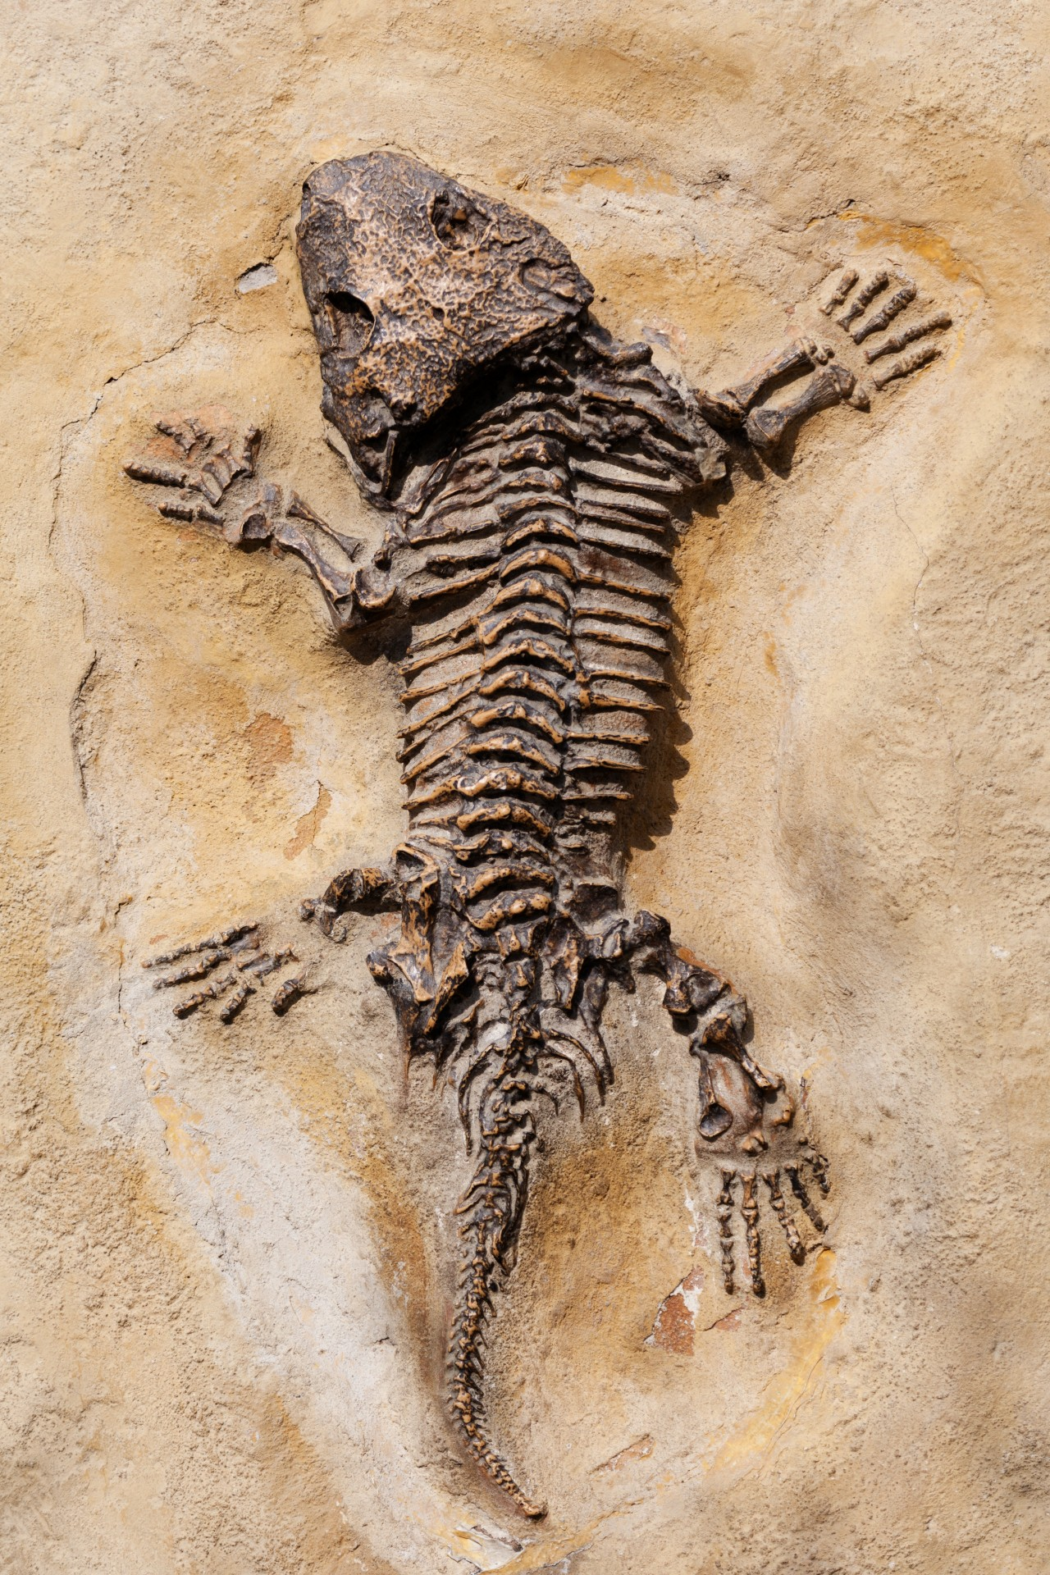

Your Inner Reptile Student Companion Worksheet

- Why is the Bay of Fundy a special place to hunt for fossils?

- How is a Tritheledont unique?

- In early development what do human fetuses have that we normally associate with chickens?

- What was the problem with the eggs of early land vertebrates?

- What was the boast of Baron George Cuvier?

- What can teeth tell us about our ancestors?

- Reptiles grow multiple sets of what in their lifetimes?

- How long did the Gorgonopsis slice and dice their way through the earth?

- What is the name of the mother of all mass extinctions?

- What do mass extinctions create for the survivors??

- What were the first types of hairs to develop in our ancestors?

- Hair first evolved as what?

- What is the gland that is responsible for skin, hair and teeth?

- What is the final change that still enriches our life today?

- How many bones make up our inner ear?

- What do labs and museums around the world use beetles for?

- How were old jawbones repurposed?

- Hadrocodium is regarded as one of the first what?

- What part of Hadrocodium was extremely large compared to the animals that came before it?

- When were mammals able to finally emerge and flourish?

Analysis Questions

What advantages did small mammals have over dinosaurs that allowed them to survive the mass extinction?

What are some of the biological features that humans have developed that the early mammals did not possess? How have these features allowed us to become the dominant mammalian species on earth?

Your Inner Reptile Student Companion Worksheet

- Why is the Bay of Fundy a special place to hunt for fossils? Its huge tides

- How is a Tritheledont unique? It is part reptile and part mammal

- In early development what do human fetuses have that we normally associate with chickens? Yolk sack

- What was the problem with the eggs of early land vertebrates? Eggs would dry out

- What was the boast of Baron George Cuvier? Show me the tooth and I can reconstruct its entire skeleton

- What can teeth tell us about our ancestors? How they lived and evolved

- Reptiles grow multiple sets of what in their lifetimes? Teeth

- How long did gorgonopsis slice and dice their way through the earth? 20 million years

- What is the name of the mother of all mass extinctions? Permian

- What do mass extinctions create for the survivors? Opportunities

- What were the first types of hairs to develop in our ancestors? Whiskers

- What did hair first evolve as? A sensory organ

- What is the gland that is responsible for skin, hair and teeth? EDA

- What is the final change that still enriches our life today? The ear

- How many bones make up our inner ear? 3

- What do labs and museums around the world use beetles for? Stripping the flesh off of bones

- How were old jawbones repurposed? They became the ear

- Hadrocodium is regarded as one of the first what? Mammals

- What part of Hadrocodium was extremely large compared to the animals that came before it? Its brain

- When were mammals able to finally emerge and flourish? 65 mya after the dinosaur mass extinction

Analysis Questions

What advantages did small mammals have over dinosaurs that allowed them to survive the mass extinction?

What are some of the biological features that humans have developed that the early mammals did not possess? How have these features allowed us to become the dominant mammalian species on earth?

